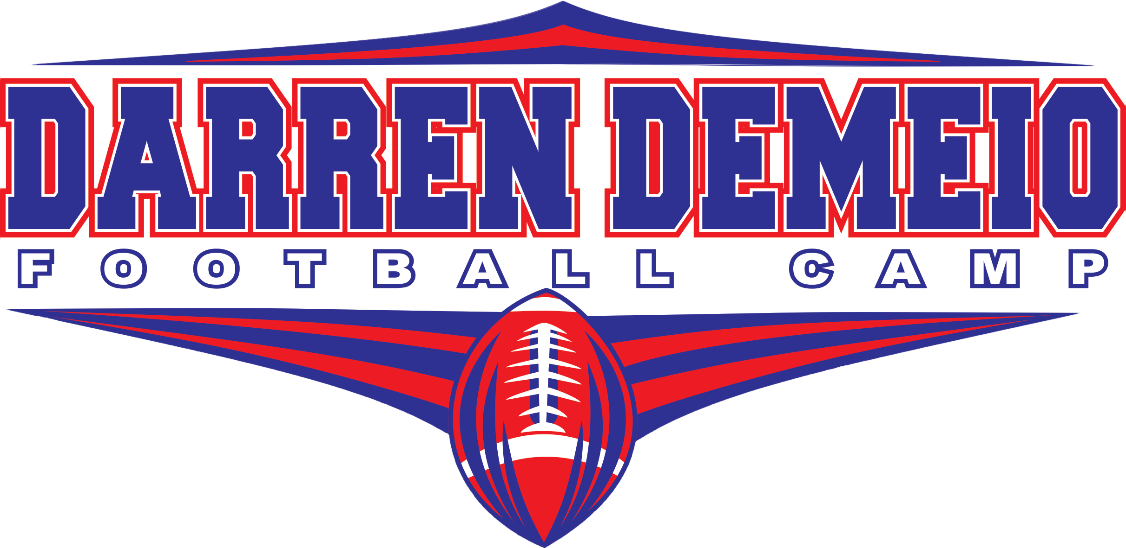
PRESENTED BY GRIT SPORTS CAMPS
FULL CONTACT YOUTH CAMP
AGES 6-15 YEARS OLD
JUNE 20 – JUNE 23

MISSION: Prepare each athlete to play football safely by teaching proper fundamentals of tackling and blocking. Develop the skills and fundamentals to play their respective position groups on offense and defense. Create learning opportunities in individual, group, and team settings. This camp is great for beginner and veteran players.
Location: Northern High School practice fields
2950 Chaneyville Rd Owings, MD 20736
Camp Hours: 8:30AM – 3:00PM Monday through Thursday
Cost: $110 registered by June 15, $130 for Walk Ups/Late Registration after June 15
(Includes 1 camp t-shirt) Make checks payable to Darren DeMeio Football Camp
Equipment: Will be issued through the youth club you will be playing for. Contact your club representative for dates and times of equipment pick up. Players are responsible for their own clothing, cleats, and equipment needed for camp each day.
Lunch: Offered for $6 a day, an athlete will receive pizza and Gatorade.
How to Register: Registration for this camp will be limited so do not wait until last minute. Walk up acceptance will be based off of openings available per age group. Visit the website, www.gritsportscamps.weebly.com, to register online or to print the paper copy to mail in registration.
Contact: Darren DeMeio – Camp Director
Head Football Coach – Northern High School
coachddemeio@gmail.com
330-801-1349
www.gritsportscamps.weebly.com
Like us on Facebook – facebook.com/DarrenDeMeioFootballCamps

